|  |  |
| --- | --- |
| **LE QUY DON PRIMARY SCHOOL**  **NAME:** …………………..……………  **CLASS: 4A….** | **THE FINAL TEST OF ENGLISH 4**  **School year: 2020 - 2021**  **Time: 35 minutes** |

|  |  |  |  |  |  |  |  |  |  |  |  |  |
| --- | --- | --- | --- | --- | --- | --- | --- | --- | --- | --- | --- | --- |
| **Mark** | **Listening** | | | **Reading** | | | **Writing** | | | **Speaking** | | **Total** |
|  | **Q1** | **Q2** | **Q3** | **Q1** | **Q2** | **Q3** | **Q1** | **Q2** | **Q3** | **Q1** | **Q2** |  | |
|  |  |  |  |  |  |  |  |  |  |  |

**PART 1: LISTENING (2.75 MARKS)**

**Question 1: Listen and tick. (0.75 mark)**

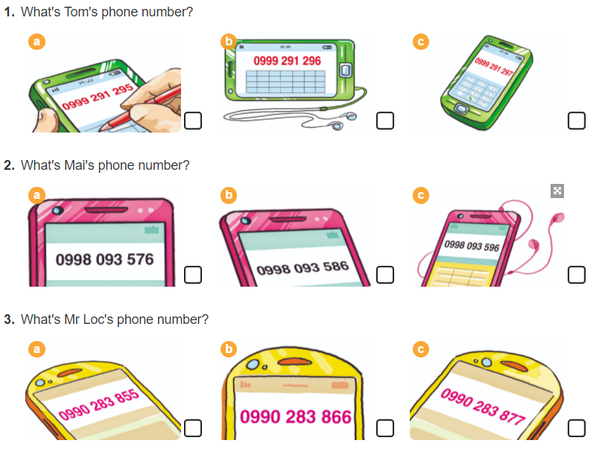

**Question 2: Listen and number. (1 mark)**

a.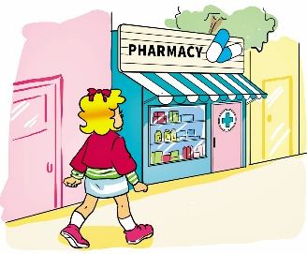 b.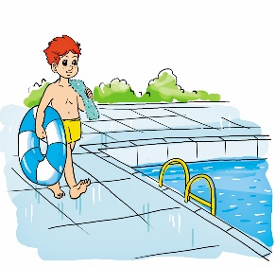 c. 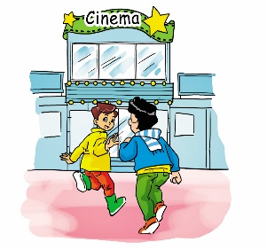 d. 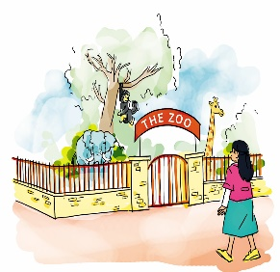

* 
* 

**Question 3: Listen and complete. (1 mark)**

1. Linda does not like ____________ because they are big.

2. Peter likes kangaroos because they are __________________

3. Mai likes monkeys because they are ______________

4. Nam does not like tigers because they are ______________

**PART 2 - READING (2.75 MARKS)**

**Question 1: Read and complete the suitable words in the gaps. There is one example. (1mark).**

Hi. My name is Loc. My classmates and I are going to have a holiday in Nha Trang next week. In the morning, we are going to swim in the sea and build sandcastles. In the afternoon, we are going to play football on the beach. We are going to have delicious seafood in the evening. We are going to have a lot of fun there!

It’s (1) _____________ soon.

1. His name is **Loc.**
2. Loc and his classmates are going to have a holiday in ________________________.
3. In the morning, they are going to ________________________________________.
4. In the afternoon, they are going to play _________________________ on the beach.
5. They are going to have ____________________________________in the evening.

**Question 2: Read and complete the passage. There is one example. (1 mark)**

|  |
| --- |
| **Orange juice drinking seven thirty family** |

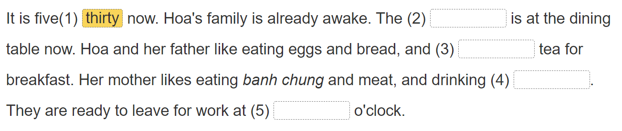

**Question 3: Read the text carefully. Tick (√) True or False. There is an example (0.75mark).**

Children’s Day is the most interesting festival for children. It is on the first of June. On this day, children do not study at school. They have a party at school or at home. They have a lot of fun. They get presents from their parents. They sing, dance, play games, eat cakes and candies at the party. Children are happy on Children’s Day.

**TRUE FALSE**

√√

1. Children’ s Day is on the 1st of July.
2. It is the most interesting festival for children.

2. On this day, children study at school.

3. They get presents from their parents.

|  |
| --- |
|  |
|  |

**PART 3 - WRITING (2.5 MARKS)**

**Question 1: Look at the pictures and the letters. Write the words. There is an example (1 mark)**

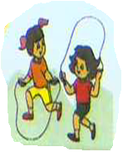 ***0. Spkpgini skipping***

|  |  |  |
| --- | --- | --- |
|  | 1. eslenatph | _ _  _ _ _ _ _ _ _ _ _ _ _ |
|  | 2. ocdtro | **_ _ _ _ _ _** |
| https://s.sachmem.vn/public/images/TA4T2SHS/U17-L1-2-3-bpxnfrblgmpepbwp.jpg | 3**.** blseou | **_ _ _ _ _ _** |
| https://s.sachmem.vn/public/images/TA4T2SHS/U16-L3-4-2-hvjzmteffkahjvky.jpg | 4**.** baerky | **_ _ _ _ _ _** |

**Question 2: Reorder the words to make sentences. There is one example (1 mark)** ***0. I’m/ years/ old./ nine 🡺 I’m nine years old.***

1**.** Where/ your/ does/ sister/ work?

🡺___________________________________________________________________________

2. What/ do/ time/ go to bed?/ you/

🡺________________________________________________________________________

3. Who/ the father/ is/ the mother?/ or/ shorter,

🡺__________________________________________________________________________

4. Do/ have/hometown?/ in your/ you/mangoes/

**🡺__________________________________________________________________________**

**Question 3: Write about you. (0.5 mark)**

1. What’s your favourite food?

**🡪______________________________________________________________________**

2. What do you do at Tet?

**🡪______________________________________________________________________**

**PART 4 - SPEAKING (2 MARKS)**

**Question 1: Getting to know each other. (1 mark)**

**Question 2: Look at the pictures and answer the questions. (1 mark)**