MA TRẬN ĐỀ KIỂM TRA CUỐI HỌC KỲ I
MÔN: TIẾNG ANH 4 NĂM HỌC: 2020 - 2021
Tên các nội dung, chủ đề, mạch kiến thức |  | Các mức độ nhận thức
 |  | Mức 1  (Nhận biết) |  | Mức 2  (Thông hiểu) |  | Mức 3  (Vận dụng) |  | Mức 4  (Vận dụng nâng cao)
 |  | TN | TL | TN | TL | TN | TL | TN | TL
LISTENING  Date, place of school, hobby, subject, ability, which grade, class | Số câu | 4 |  | 4 |  | 4
 | Số điểm | 0.25 |  | 0.25 |  | 0.25
 | Câu số | Q1 (1,2,3,4) |  | Q2 (1,2,3,4) |  | Q3 (1,2,3,4)
READING  Subject, day, hobby, nationality | Số câu | 3 |  | 4 |  | 3
 | Số điểm | 0.25 |  | 0.25 |  | 0.25
 | Câu số | Q1 (1,2,3) |  | Q2 (1,2,3,4) |  | Q1 (1,2,3)
WRITING  Subject, day, hobby, nationality, which grade, class | Số câu |  |  | 3 |  | 3 |  |  | 4
 | Số điểm |  |  | 0.25 |  | 0.25 |  |  | 0.25
 | Câu số |  |  | Q1 (1,2,3) |  | Q1 (1,2,3) |  |  | Q2 (1,2,3,4)
SPEAKING  Subject, day, hobby, nationality, which grade, class | Số câu |  |  | 2 |  | 2 |  |  | 4
 | Số điểm |  |  | 0.25 |  | 0.25 |  |  | 0.25
 | Câu số |  |  | Q1 (1,2) |  | Q1 (1,2) |  |  | Q1 (1,2,3,4)
Tổng số câu  Tổng số điểm |  | 7  1.75 |  | 13  3.25 |  | 12  3.0 |  |  | 8  2.0

ĐỀ CƯƠNG ÔN TẬP KIỂM TRA CUỐI HỌC KỲ I
MÔN: TIẾNG ANH 4 NĂM HỌC: 2020 -2021
I. Vocabulary
flying kite, singing, skipping, doing, reading, drawing a picture, play badminton, ride a bike, take a photo, write a dictation, play the piano, subjects, English, Maths, Vietnamese, Science, PE, Music, Art, IT, Monday, Tuesday, Wednesday, Thursday, Friday, Saturday, Sunday, January, February, March, April, May, June, July, August, September, October, November, December, England, Japan, America, Australia, Malaysia, English, Japanese, American, Australian, Malaysian.
II. Sentence patterns
1. What can you do?
2. What’s your hobby?
3. When’s your birthday?
4. When do you have English?
5. What is the name of your school?
6. What day is it today?
7. What do you do on Sundays?
8. What do you like doing?
9. What subjects do you have today?
10. Where were you yesterday? What did you do?

LE QUY DON PRIMARY SCHOOL  Name: ____________________________  Class: 4A_______ | THE FIRST TERM TEST FOR GRADE 4  School year: 2020 - 2021  Time: 35 minutes

Marks | Listening |  |  |  | Reading and Writing |  |  |  | Speaking | Total
 | Q.1 | Q.2 | Q.3 | Q.4 | Q.5 | Q.6 | Q.7 | Q.8

PART 1. LISTENING (3 marks)
Question 1: Listen and number. (1 mark)
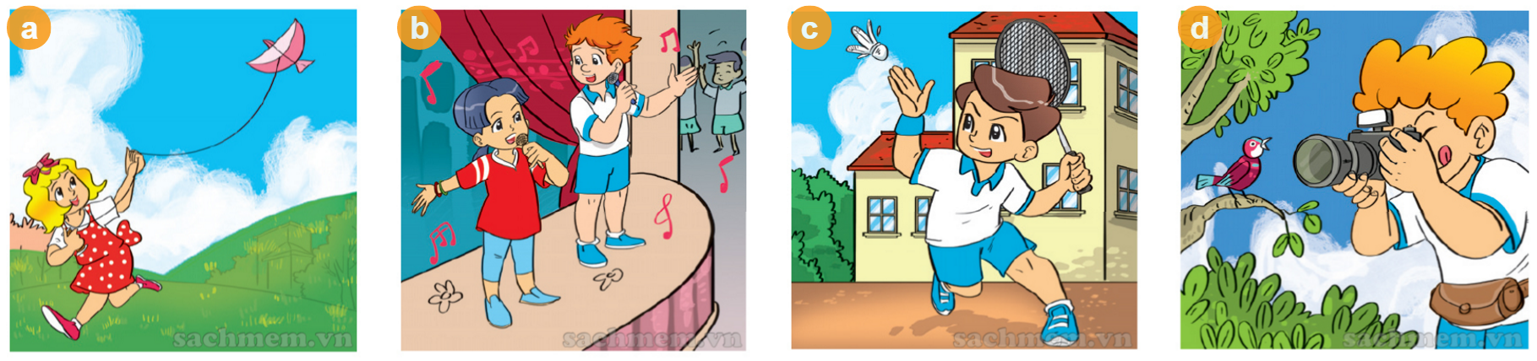

Question 2: Listen and tick. (1 mark)
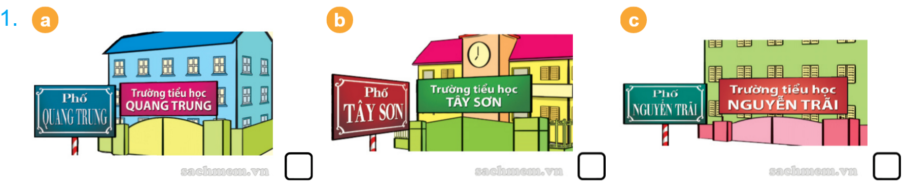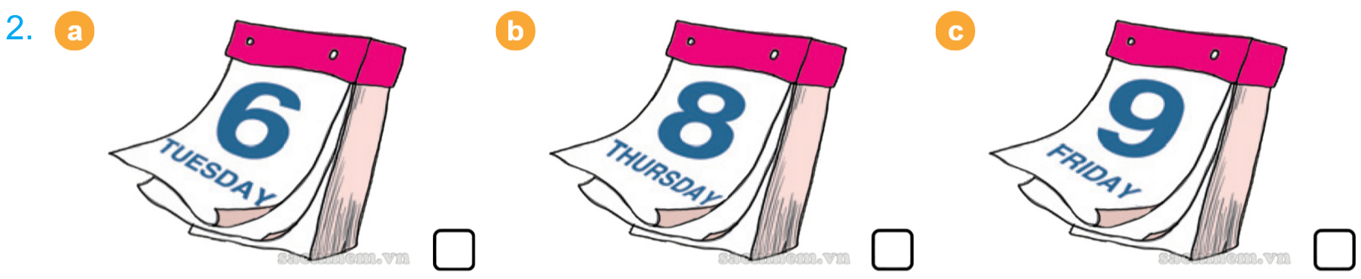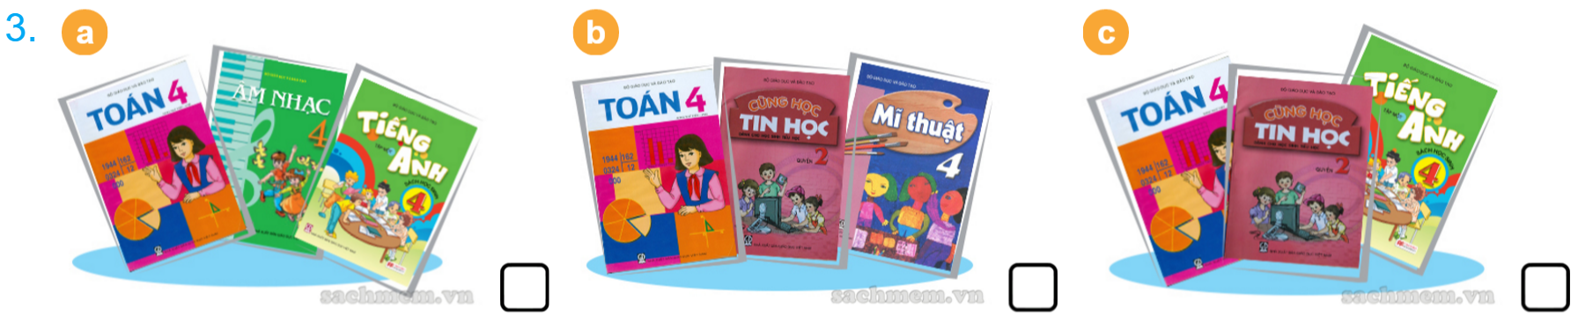
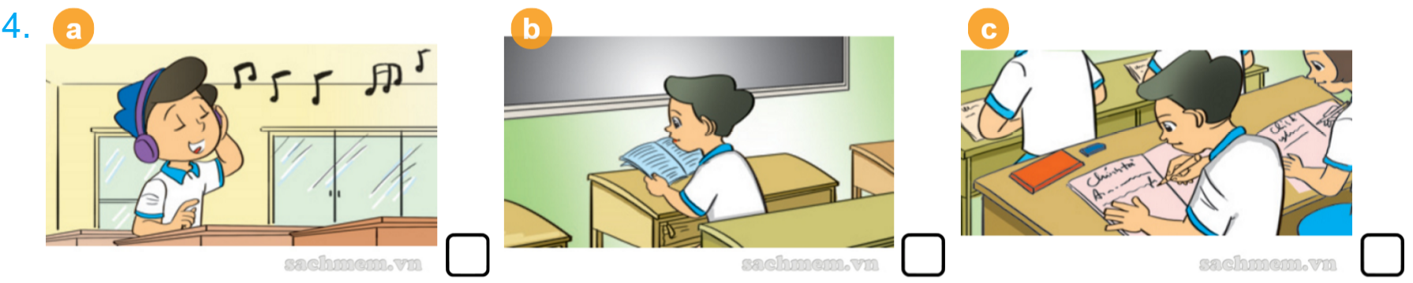
Question 3: Listen and complete. (1 mark)
Peter : Hi, Mai. Where’s Tom?
Mai : He’s (1) …………………….. the classroom.
Nam : What’s he (2) ……………………..?
Mai : He’s reading.
Nam : What are you reading?
Tom : I’m reading a (3) ……………………...
Nam : Let’s play (4) ……………………..., Tom.
PART 2. READING (2.5 marks)
Question 1: Read and complete. There is one example. (1 mark)
England | friend | singing | February | Music
This is my (0) …………………….., Linda. She is from (1) ……………………... She is ten years old. Her birthday is on the third of (2) ……………………... Her favorite subject is (3) ……………………... Her hobby is (4) ……………………... She can sing many Vietnamese songs.
friend
Question 2: Look and put a tick () or a cross (). There are two examples. (0.75)
Examples |  | I can’t draw a cat.
 |  | My birthday is in April.
1. |  | He can ride a bike.
2. | 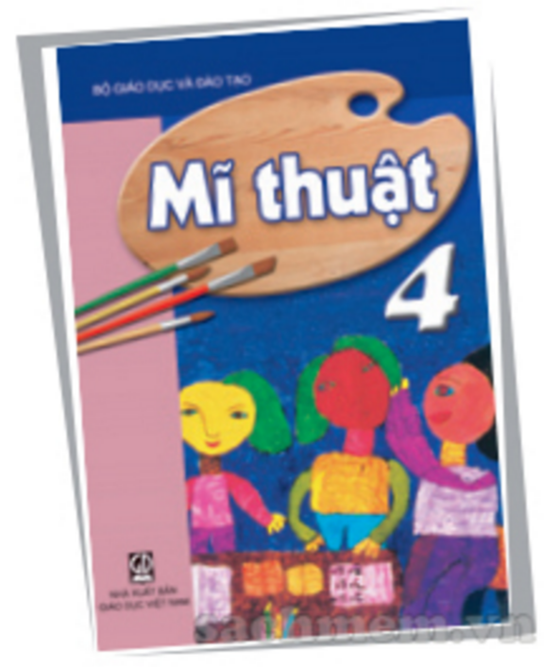 | My favourite subject is Art.
3. | 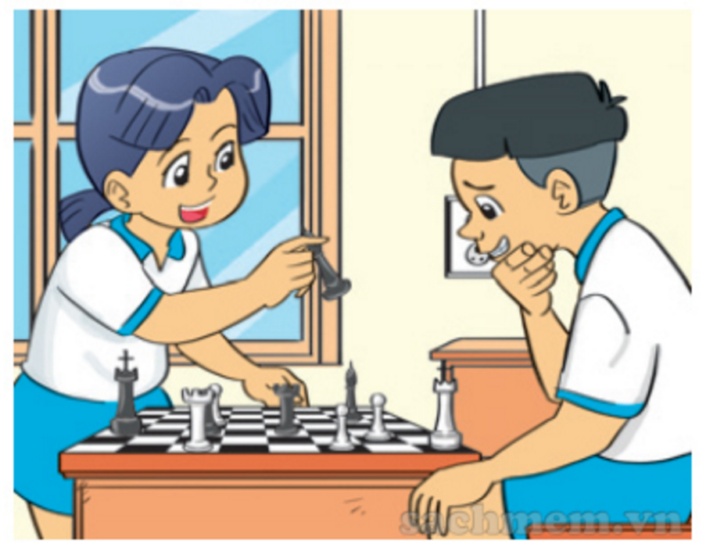 | They like playing chess.
Question 3: Read and complete. There is one example. (0.75 mark)
Name: Lan
Nationality: Vietnamese
School: Le Loi Primary School
School address: Le Loi Street, Hoan Kiem District, Ha Noi
Hello. My name is (0) ……………………... I’m from Ha Noi, Viet Nam.
I’m (1) ……………………... I study at (2) ………………Primary School.
It’s a big school in (3) ……………………..……………………..
Lan
PART 3. WRITING (2.5 marks)
Question 1: Look at the pictures and write the words. (1 mark)
1. | 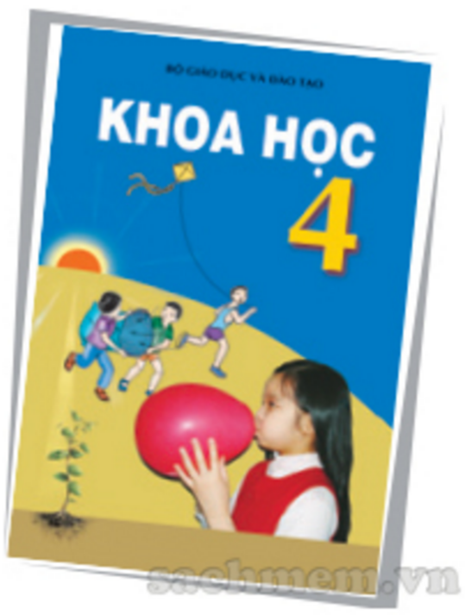 | I have …………………….. on Mondays.
2. |  | I can play ……………………....
3. | 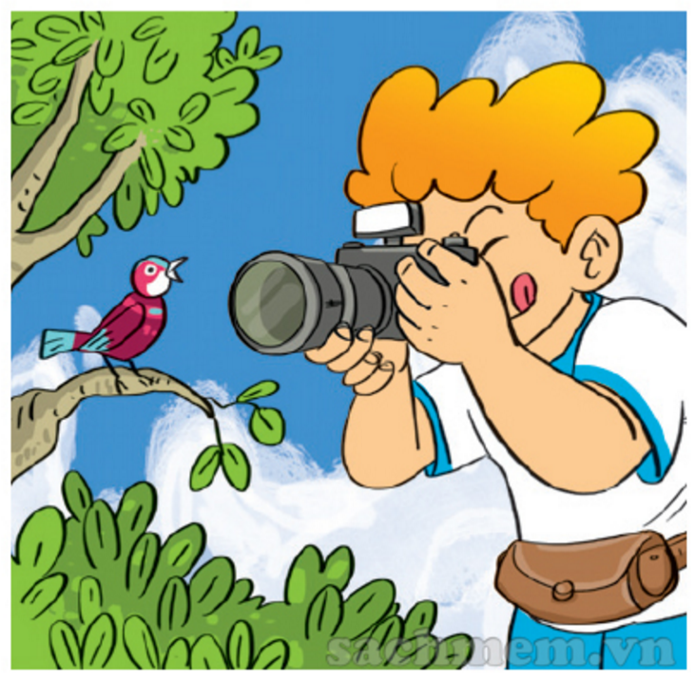 | He likes …………………….. photos.
4. |  | She is writing a ……………………....
Question 2: Reorder the words to make sentences. There is one example. (1 mark)
Example: cook/ she/ can/. She can cook.
1. music/ My/ is/ hobby/ to/ listening/.

2. Maths/ you/ have/ do/ When/?

3. I/ in/ afternoon/ help/ parents/ the/ my/.

4. was/ home/ yesterday/ She/ at/ evening/.

Question 3: Write about you. (0.5 mark)
1. What class are you in?

2. What did you do yesterday?

PART 4. SPEAKING (2 marks) (5 minutes)
1. Getting to know each other.
2. Talking about a familiar object.
3. Describing the picture.
HƯỚNG DẪN CHẤM BÀI KIỂM TRA CUỐI HỌC KỲ I
MÔN: TIẾNG ANH 4 NĂM HỌC: 2020 - 2021
PART 1. LISTENING (3 marks)
Question 1: Listen and number. (Part 4, p. 49, Track 58) (1 mark)

a. 2
b. 4
c. 1
d. 3
Question 2: Listen and tick. (Part 1, p. 70, Track 85) (1 mark)

1. c
2. b
3. a
4. b
Question 3: Listen and complete. There is one example. (Part 1, p. 58, Track 69) (1 mark)

1. in
2. doing
3. book
4. football
PART 2. READING (2.5 marks)

Question 1: Read and complete. There is one example. (1 mark)

1. England
2. February
3. Music
4. singing
Question 2: Look and put a tick () or a cross (). There are two examples. (0.75 mark)

1.
2.
3.
Question 3: Read and complete. There is one example. (0.75 mark)

1. Vietnamese
2. Le Loi Primary School
3. Le Loi Street, Hoan Kiem District, Ha Noi

PART 3. WRITING (2.5 marks)
Question 1: Look at the pictures and write the words. (1 mark)

1. Science
2. badminton
3. taking
4. dictation
Question 2: Reorder the words to make sentences. There is one example. (1 mark)
1. My hobby is listening to music.
2. When do you have Maths?
3. I help my parents in the afternoon.
4. She was at home yesterday evening.

Question 3: Write about you. (0.5 mark)
Answers vary.
PART 4. SPEAKING (2 marks) (5 minutes)
1. Getting to know each other.
The examiner asks the three following questions:
- What class are you in?
- What can you do?
- What’s your hobby?
2. Talking about a familiar object.
- Talk about you and your school subjects.
3. Describing the picture.
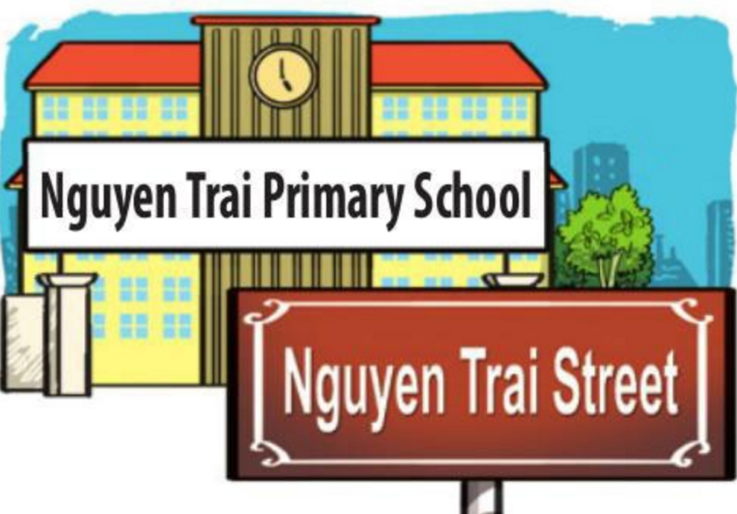
- What is the name of your school?
- Where is it?
- Is it big?
- The end -

Ban Giám hiệu Tổ trưởng Tổ Tiếng Anh Người ra đề

